Cells

Cell Theory
- Cells are the basic unit of structure and function.
- All life is made of cells.
- All cells come from other cells

Prokaryote vs Eukaryote
Prokaryote
- Lack a nucleus and membraned-organelles - Simple - Unicellular
- EX: bacteria, archaea
Eukaryote
- Have a nucleus and membraned-organelles - Complex - Uni and Multi-Cellular
- EX: protists, fungi, plants, animals

Organelles
Exterior
- Cell membrane – selectively permeable (only certain things in and out) – maintains homeostasis
- Cell Wall – rigid support and structure
Interior
- Nucleus – controls cell, stores DNA
- Ribosome – makes proteins
- Endoplasmic Reticulum (ER) – chemical reactions
- Mitochondria – makes energy through respiration
- Cilia/Flagella – movement
- Plasmid – ring of genetic info in prokaryotes
- Chloroplast – makes food using sunlight in photosynthesis
- Lysosome – breaks down waste
- Cytoplasm – “filling” of cells
- Golgi Apparatus – transports
- Vacuoles – store water

ALL Cells have – cell membrane, cytoplasm, ribosomes, genetic info

Plant vs Animal
- Animal cells lack a cell wall and chloroplasts

Label the Cells

Animal
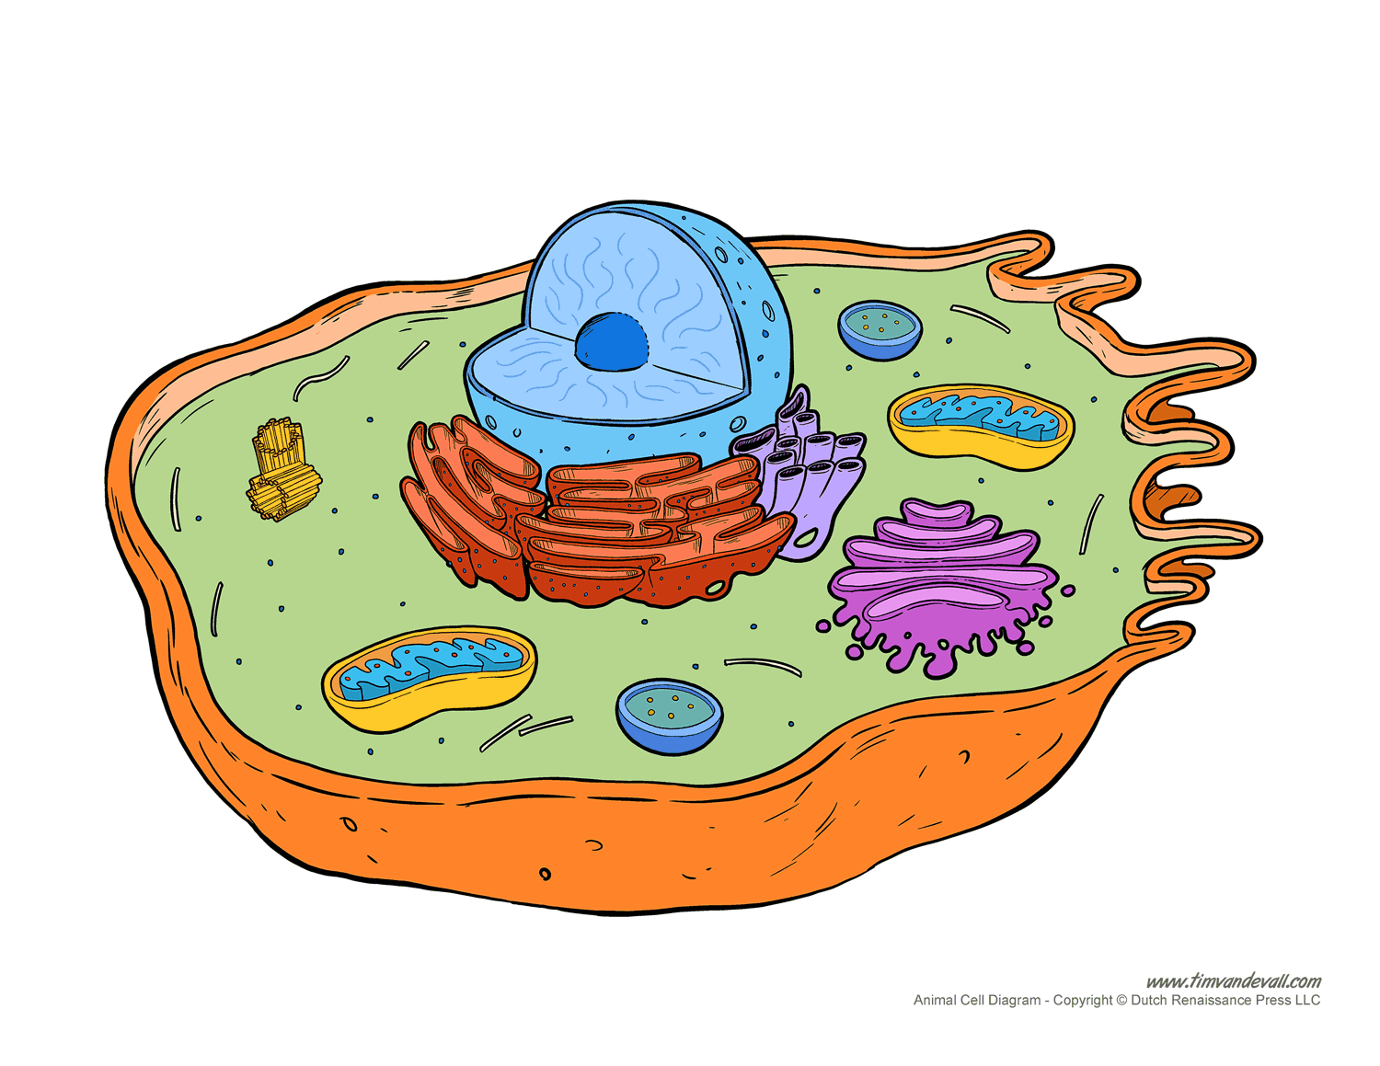

Plant
