Earth Science Mid-Term Study Guide

** Complete this for a grade!!**

Intro to Earth

- Seasons
  - Describe how seasons are caused.
  - Why are seasons in the Northern Hemisphere opposite those in the Southern?
- Latitude vs Longitude
  - Which ways do they measure?
  - Be able to locate a point on a map
- Draw and label a diagram of the Earth with its 4 layers.
- Earth’s Movement:
  - Rotation vs Revolution
  - Nutation vs Precession
  - Barycenter
- How is solar energy essential to plants?
- Compare and contrast fission and fusion.
- What does each of the following measure: grams, liters, seconds, meters.

Rocks

- 3 rock types
  - How they are formed
  - Examples of each
- Rock Cycle: complete the chart
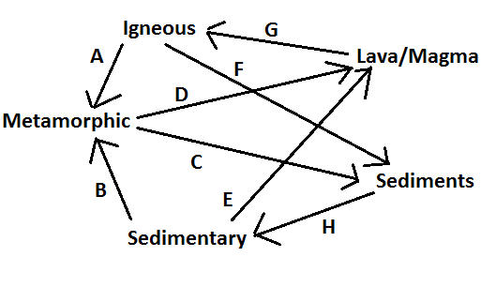
- What are the 3 organic rocks, and why are they called that?
- Define the following: luster, streak, fracture, cleavage, density
- Compare Erosion and Weathering
  - Why are wind, water, and gravity agents of erosion and not weathering?

Plate Tectonics

- Define lithosphere and asthenosphere.
- What is continental drift?
- Name and provide the Latin-root origin for the ancient giant landmass and ocean.
- 3 Types of Plate Boundaries
  - Describe the 3 types
  - Create and label a simple diagram of continental and oceanic subduction
- What are the 3 forms of convergent boundaries and what does each form?
Earthquakes
- List the 3 types of stress and their associated strain.
- List the 3 types of faults and their associated stress.
- Explain the relationship between earthquakes and subduction zones.
- Draw and label an earthquake diagram.
- How does the subduction of crustal plates influence the rock cycle?
- Why are seismic waves of an earthquake more strongly felt at the epicenter of an earthquake?

Volcanoes
- Describe the differences between lava and magma.
- What is the relationship between volcanoes, earthquakes, and the lithosphere?
- Define: tephra, lahar, pyroclastic flow
- Define and compare the 3 volcano types
- Compare and contrast a crater and a caldera.
- Define the 3 “life stages” of a volcano.
Tectonic Disasters
- Describe and provide examples of the following:
  - Tsunamis
  - Sinkholes
  - Landslides

Impact on Lithosphere
- Describe the ways we are affecting the lithosphere.
- What methods are we using to fix the damage we have caused?
- What are the 4 fossil fuels?
- Describe the conventional methods of energy.
- Describe the alternate methods of energy.
- Provide reasoning as to why we should and should not use conventional methods. Repeat for alternate.

