Hydrosphere

What does Water Balance mean?
_____________________________________ = ____________________________

Water Cycle

Water is ______________ moving among the ___________, the _________________, the solid _______________, and the ___________________.

Parts of the water cycle

- Evaporation – water _______________ into _______________ into the________________
- Precipitation – ___________ or _____________ water from the ____________
- Infiltration - water___________ through the __________________
- Transpiration - water____________ from ___________
- Runoff – when _____________________ hits the ___________and is not _______________

Distribution of the Water on Earth

- ________of Earth is ________
- ______ in the __________
- ________ is _________________
- ________ in _______________________
- ________ in _______________________
- ________ in _______________________________________________

Water Supply and Use - How is water used?
___________-___________________
___________-___________________
___________-___________________

Ocean Currents
Ocean circulation also influences climate
- Ocean ___________: ocean water ____________ heat in the ________ with the ___________________.
- ___________ circulation: a _____________ current __________ in the ______
  - ___________, fresher __________moves along the _________ and carries __________ to _________________
- North American Deep Water (NADW): the ____________ portion of the _________________________________________________________.
  - _________, __________, __________ water that __________________
  - moves _____________ beneath the ___________________________

NADW is vulnerable
- If ___________________ ice melts, _________________________ would _______ surface waters, making them _______________, and stopping ___________________. – This has occurred in the _________________

Ocean Currents:
- Primary Forces--start the water _________________

- Secondary Forces--__________________________________________________________

Warm and Cold Currents
- Warm ocean currents: _____________ water from ______________ to _______________.
- Cold ocean currents: ________________ water from _____________ toward the ____________________.
- The __________________, is a ___________-water ___________ that moves up the ___________________ coast of the _____________________________

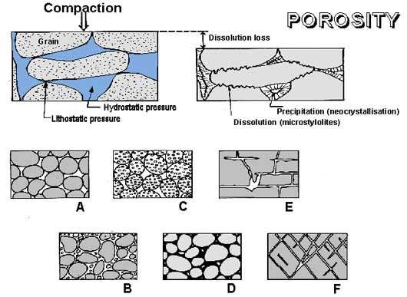
Groundwater
Movement of water underground

Porosity: percentage of __________________ showing how much __________ is _____________

Permeability: _____________ can ________________ through _________________ pore spaces

Clay: _______________amount of pore ___________of any ________ type – not ____________________

- Zone of Aeration – area ________ the _____________ where _______________________ passes ______________

- The water table is the _________________ of the ________________ of ______________
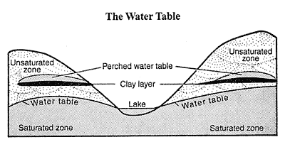
- Zone of Saturation – area where the ____________________________ are _______________ with ____________

- Groundwater is the ___________ within the _________ of _____________________
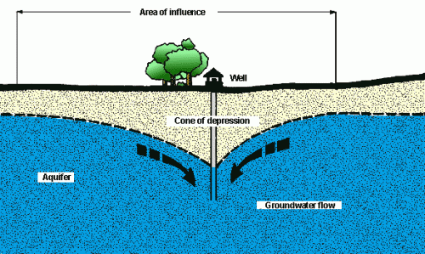
- Aquifer : ___________________ layer of _____________________ permeable rock (______________, ________________ or _____________) from which __________________ can be extracted using a _______________________.
- A cone of depression occurs in an _______________ when a lot of ______________ is _____________________ from a _______________________.
- Artesian well: ______________ rises on its ____________ under _________________.
- ____________________can cause the _________________________ to be ______________
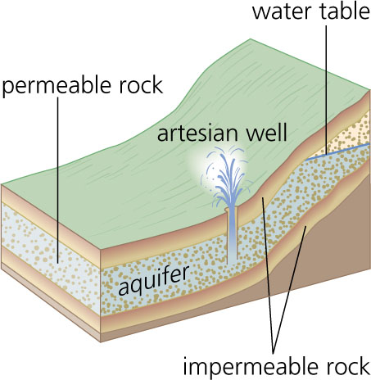
Problems with Groundwater

- Withdrawing ______________________________
- __________________ contaminating the _____________
(______________,________________, &______________)
- _________water________________ (___________________
From ocean_____________ the _______________________)_.

Caverns

- A _________ is a _____________ formed _______________________ chamber when ____________ is withdrawn _______________ it ________________.
- ________________forms most ____________ at or below the _____________________________________.

- Sinkholes:___________ near the __________________ causing _______________________.

A stream’s profile
- Headwater (_____________) – at the ______________ of a stream
- ________________ are ______________________
- Higher ___________________ ______________________
- Fish found:________________________
- Mouth (______________)– at the ______________of a _____________________
- Murky _________________
- _____________________ dissolved __________________
- Fish found:_______________________________________
Watershed
*An area of _______________ that contains a __________________ set of __________________ and __________________________.
Tributary –a ___________ that _____________ into another ______________
Drainage Basins
*A __________________ basin is the ________________ area that _______________ water to a ______________________.

Base Level
Base level - ________________ to which a ___________ can ____________
- Ultimate base level is ___________________
Temporary or local base levels

- _________________
- _________________
Meandering Stream
_________ moving __________ located in the __________________ or ______________

Three ways streams erode channels

- _______________
- _______________
- ____________________________________________
Controlling Floods

Natural Levees

- A natural levee _____________ a ____________ and helps to contain its __________________________, except during __________________
Artificial Levees
- ___________________ mounds are _________________ on the____________ of a ________________, increasing the amount of ___________________ it can hold.

Results of Floods
- Floodplains– areas where ____________ floods the _____________________
- Provides a _____________________ of _____________________ silt to________________ areas.
- Recharge _________________________________.
- Kill and causes ___________________________________________________

Human activities causing Flooding
*____________________________________________________________
*______________________________________________
*______________________________________________
*____________________________________________________________
*______________________________________________
*____________________________________________________________
*____________________________________________________________
*______________________________________________

Drought
41% of people live in river basins that do not have enough fresh water!
  - ___________________________________________________
  - ___________________________________________________
  - ______________________________________________________________________________________________________
  - ______________________________________________________________________________________________________

Causes of a Decrease in Available Water
- Dry ______________
- _______________- a period in which ______________ is much __________ and ________________ is much _______________.
- ________________- drying of __________ because of such ______________ as ___________________ and _________________.
- ________________________- low per capita ___________________ of _______________ caused by ____________________________.

